Project Planning Phase
Product Backlog, Sprint Schedule and Estimation
Date | 8 October 2026
Student Name | OviyaShree
Project Name | Metro Ticket Generating System in ServiceNow
Maximum Marks

Product Backlog, Sprint Schedule and Estimation
Sprint | Functional Requirement (Epic) | User Story / Task | Story Points | Priority | Student Name
Sprint-1 | Catalog Form Setup | Create the ticket booking catalog item with Source, Destination, Passenger Type, Number of Tickets. | 5 | High | Mohamed Radhuwan
Sprint-2 | Fare Logic Script | Write fare calculation logic and field validations. | 5 | High | Mohamed Radhuwan
Sprint-3 | QR Code Integration | Generate QR code for the digital ticket. | 5 | High | Mohamed Radhuwan
Sprint-4 | Station Details Mapping | Map station details and auto-populate fields. | 3 | Medium | Mohamed Radhuwan
Sprint-5 | UI Pages | Build user-facing UI pages, Flow Designer and Notifications. | 3 | Medium | Mohamed Radhuwan
Sprint-6 | UAT & Deployment | User acceptance testing and deployment. | 2 | High | Mohamed Radhuwan
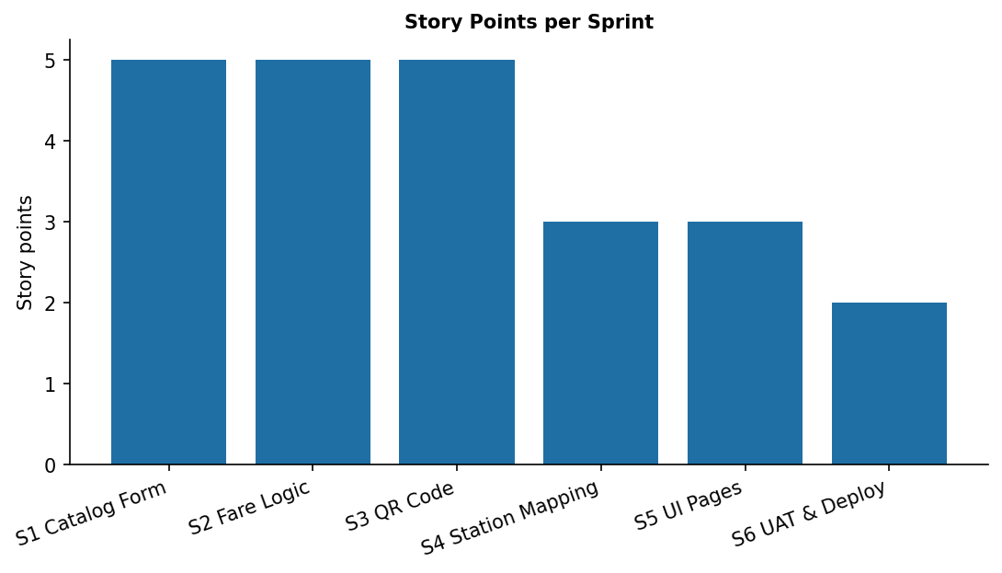
Figure 1: Sprint schedule and story-point representation.
Project Tracker
Work Item | Status | Validation
Catalog form | Completed | Ticket booking catalog item with required variables created.
Fare logic | Completed | Fare calculated automatically and matched.
QR code | Completed | Digital ticket QR code generated.
Station mapping | Completed | Station details mapped to bookings.
Validations | Completed | Mandatory and auto-populate rules working.
Flow & Notifications | Completed | Confirmation sent after booking.
UI Pages | Completed | User-facing pages configured.
UAT & deployment | Completed | Scenarios accepted.

